**Ganeti Setup and Install**

***Step 1: LVM setup***

Create LVM and Partitions suitable for 30gigs of space or more. The volume group is required to be at least 20GiB.

If you haven't configured your LVM volume group at install time you need to do it before trying to initialize the Ganeti cluster. This is done by formatting the devices/partitions you want to use for it and then adding them to the relevant volume group:

# pvcreate /dev/sda3

# vgcreate vmvg /dev/sda3

PV VG Fmt Attr PSize PFree

/dev/sda3 vmvg lvm2 a-- 34.88G 34.88G

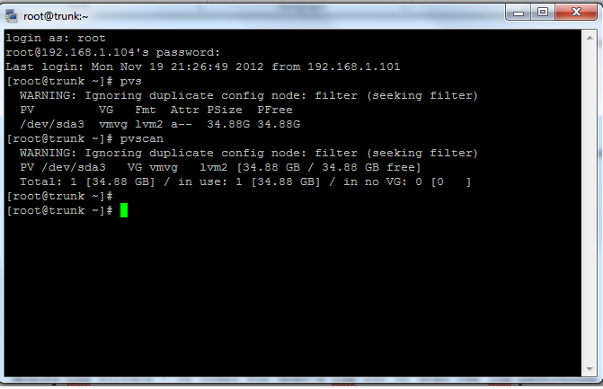

Modify lvm filters - /etc/lvm/lvm.conf, you may modify and uncomment the /dev/cdrom line.

filter = [ "r|/dev/cdrom|", "r|/dev/drbd[0-9]+|" ]

***Step 2: Edit Local hosts***

When setting up your local hosts file #vi /etc/hosts you need to use FQDN (fully qualified domain names). Example: mynode.gatewayname mynode

136.145.54.115  gnt-node1.gateway gnt-node1  
136.145.54.116  gnt-node2.gateway gnt-node2  
136.145.54.117  gnt-node3.gateway gnt-node3  
127.0.0.1       localhost.localdomain localhost  
::1             localhost6.localdomain6 localhost6

***Step 3: Xen install***

Install Xen and Xen-kernel setup the grub and create a Bridge to Eth0. Setup bridged networking by editing /etc/sysconfig/network- scripts/ifcfg

“See Xen Handout”

***Step 4: Install YUM-able packages:***

# yum -y groupinstall “Base” “Development Tools”

# yum -y update

# yum -y install kernel-xen xen drbd83 bridge-utils iproute iputils python pyOpenSSL gcc python-devel python-pycurl  kmod- drbd83 kmod- drbd83-xen libvirt  openssl-devel

Some of these packages might not work right away, for that we need to setup another Repo for Centos.

# rpm --import [http://elrepo.org/RPM-GPG-KEY-elrepo.org[ (external link)](http://elrepo.org/RPM-GPG-KEY-elrepo.org)](http://elrepo.org/RPM-GPG-KEY-elrepo.org)

# rpm -Uvh http://elrepo.org/elrepo-release-5- 3.el5.elrepo.noarch.rpm[ (external link)](http://elrepo.org/elrepo-release-5-3.el5.elrepo.noarch.rpm)

# yum -y install kmod-r8168

***Step 4.2: Installing other python packages***

# wget http://download.fedora.redhat.com/pub/epel/5/i386/epel-release-5-4.noarch.rpm

# rpm -ivh epel-release-5-4.noarch.rpm

# rpm --import /etc/pki/rpm-gpg/RPM-GPG-KEY-EPEL

# sed -i "s/enabled = 1/enabled = 0/g" /etc/yum.repos.d/epel.repo

# yum -y install pyOpenSSL python-simplejson pyparsing python-inotify python-ctypes python-pycurl python-paramiko debootstrap socat

***Step 4.3: DRBD edits***

Now that you have DRBD installed you need edit a small change in the

modprobe.conf

#vi /etc/modprobe.conf

Add the options

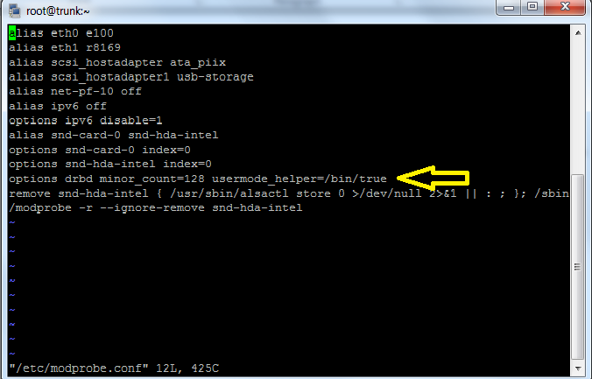 options drbd minor_count=255 usermode_helper=/bin/true

***Step 5: Installing Ganeti***

Before you download Ganeti you need to make the directories for the program.

# mkdir /etc/ganeti /srv/ganeti /srv/ganeti/os /srv/ganeti/export

Now you can use this Repo to download the version of Ganeti you are looking for.

[***http://jfut.integ.jp/linux/ganeti/noarch/***](http://jfut.integ.jp/linux/ganeti/noarch/)

Now we just simply use the wget option on the downloadable RPMS

# wget http://jfut.integ.jp/linux/ganeti/noarch/ganeti-2.6.1- 1.el5.noarch.rpm

# wget http://jfut.integ.jp/linux/ganeti/noarch/ganeti-instance- debootstrap-0.7-2.el5.noarch.rpm

# rpm -ivh ganeti-2.6.1-1.el5.noarch.rpm

# rpm -ivh ganeti-instance-debootstrap-0.7-2.el5.noarch.rpm

***Step 5.1: SSL certs Starting Ganeti***

At this point, Ganeti is installed.  The final step is to fix an SSL error by regenerating the certificates:

# openssl req -new -x509 -days 1825 -keyout server-key.pem -out server-cert.pem

**Follow the prompts**

# openssl rsa -in server-key.pem -out server-key-nopass.pem

# cat server-key-nopass.pem server-cert.pem >/var/lib/ganeti/server.pem

# openssl req -new -x509 -days 1825 -keyout rapi-key.pem -out rapi-cert.pem  
**Follow the prompts**

# openssl rsa -in rapi-key.pem -out rapi-key-nopass.pem

# cat rapi-key-nopass.pem rapi-cert.pem > /var/lib/ganeti/rapi.pem

***Start/restart*** the service to see if everything went smoothly.

# service ganeti restart

Creating the master / cluster

# gnt-cluster init [NAME OF CLUSTER MASTER]

example: gnt-cluster init myclustermaster

If you get any errors from the restart try to initialize the cluster first. If there are any errors after that, it should give you an idea what you need to install / do / or fix.

Adding a Node to the cluster.

# gnt-node add <NODENAME>

gnt-node add node2

***Step 6: Setting up virtual instances and Ganeti monitoring***

Now we are setup to create vm instances using Ganeti.

# gnt-instance add -t drbd -n node1:node2 -o debootstrap+default --disk 0:size=8G -B vcpus=2,maxmem=1024,minmem=512 instance1

It is recommended to try and use an instance Image software for monitoring Ganeti

there are a few out there in distribution but the one listed below works very well.

http://code.osuosl.org/projects/ganeti-image/